PRACTICAL 3 OF CCP

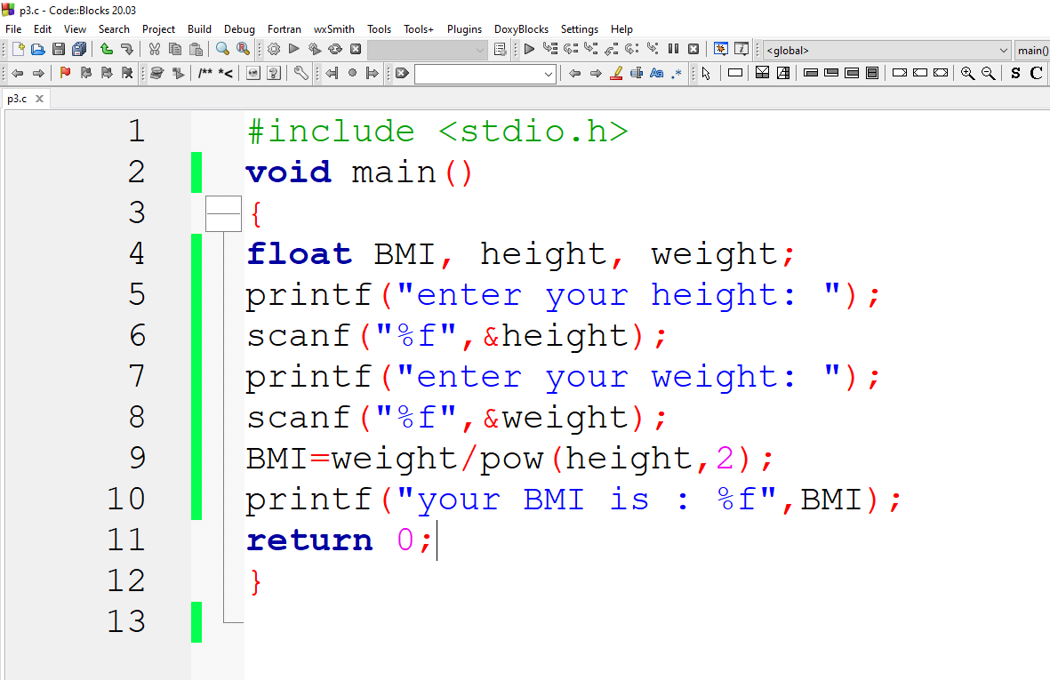

OUTPUT OF THE FOLLOWING PROGRAM

